
Editorial Board Member Certificate
We are pleased to confirm that
Sam Vaknin,
Has performed as Editorial Board Member for the following Auctores journals since: 2025-2026
Psychology and Mental Health Care
Auctores is a publisher of open access, international, academic journals. We rely on active researchers, highly qualified in their field to provide review reports and support the editorial process. Editors are eventually responsible for the quality of their journal’s content. Auctores believes that editorial board member acts as a heart of the journal thus maintaining the standards and drive the journal to success.
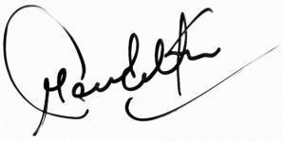

Publisher and President Date: May 16, 2026

